Frontend – Theory Assignment 1
Q1. Explain the HTTP Request–Response Cycle with a suitable diagram. Describe the major steps involved when a client (browser) requests a resource from a web server and receives a response.
Answer: Whenever a website is opened, the browser and the server exchange information using a fixed pattern called the request–response cycle. In simple terms, the browser first "asks" the server for a page, and the server "answers" by sending back the required content. This back-and-forth is the foundation of how the web works.
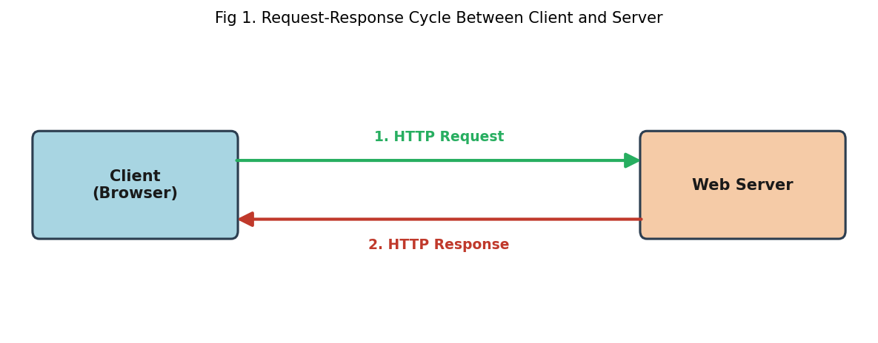
The cycle can be broken down into the following stages:
- A user types a URL in the address bar or clicks on a hyperlink.
- The browser converts this action into a formal HTTP request, adding details such as the method (GET/POST), headers, and the resource path.
- This request travels over the network and reaches the correct web server.
- The server interprets the request, retrieves or generates the requested resource (this may involve reading a file, querying a database, or running server-side code).
- The server packages the result into an HTTP response, which includes a status code (e.g., 200 OK) along with the actual content — HTML, CSS, JS, JSON, images, etc.
- The browser receives this response, renders it, and displays the final page to the user.
Q2. Briefly explain the purpose and key features of HTML, CSS, JavaScript, Bootstrap, jQuery, and React.js.
HTML: Stands for HyperText Markup Language and forms the skeleton of any web page. It defines content using tags for headings, paragraphs, links, images, tables, and forms, giving the browser a structure to render.
CSS: Cascading Style Sheets handle the visual presentation of a page — things like colour schemes, typography, spacing, borders, and overall layout — separating design from content.
JavaScript: A scripting language that brings interactivity to a page. It can update content on the fly, validate form input, respond to clicks, and communicate with servers without reloading the page.
Bootstrap: A CSS/JS framework offering a grid system and pre-built components (navbars, buttons, cards, modals) so developers can assemble responsive layouts quickly instead of styling everything from scratch.
jQuery: A lightweight JavaScript library that simplified DOM manipulation, event handling, AJAX calls, and animations through a concise syntax, at a time when writing plain JavaScript for these tasks was verbose.
React.js: A component-based JavaScript library for building interactive UIs. It uses a virtual DOM to efficiently update only the parts of a page that change, and encourages building interfaces from small, reusable pieces.
Q3. What are client-side technologies and server-side technologies? Explain the difference between them with suitable examples.
Answer: Client-side technologies execute inside the user's own browser. Their job is to build everything the visitor sees and interacts with directly — layout, styling, and on-page behaviour. Common examples are HTML, CSS, and JavaScript.
Server-side technologies, in contrast, run on the machine hosting the website. They handle tasks the browser cannot do on its own, such as talking to a database, authenticating users, and generating dynamic content before it is sent to the browser. Examples include Node.js, PHP, Java (Spring), and Python with Django or Flask.
Point | Client-Side | Server-Side
Where it runs | Inside the user's browser | On the hosting web server
Primary role | Presentation and interactivity | Data processing and business logic
Visible to user | Yes, source can be viewed | No, code stays on the server
Typical examples | HTML, CSS, JavaScript | Node.js, PHP, Django/Flask, Spring

Q4. What are block-level elements in HTML? Explain their characteristics and provide at least three examples.
Answer: A block-level element is one that occupies its own line in the document flow and stretches to fill the full width available inside its parent container, pushing any following content to the next line.
Key characteristics:
- Always begins on a new line, regardless of surrounding content.
- Expands to take up the entire width of its parent by default.
- Can contain other block-level elements as well as inline elements.
- Used to build the overall skeleton/layout of a page (sections, containers, headings).
Examples: <ul>, <table>, <form>, <h2>, and <footer>.
Q5. What are semantic elements in HTML? Explain their importance in web development and provide suitable examples.
Answer: Semantic elements are tags whose name itself conveys the role of the content they wrap, instead of being a generic, meaning-less container. For instance, using <nav> tells both the developer and the browser that the enclosed links form the site's navigation.
Why they matter:
- They make the HTML source easier for other developers to read and maintain.
- Screen readers and other assistive technologies rely on them to help visually impaired users navigate a page.
- Search engines use semantic structure to better index and rank pages (SEO benefit).
Examples: <header>, <nav>, <main>, <article>, <aside>, <figure>, and <footer>.
Q6. Write HTML code to create a table with Sr. No., Name, Designation, and Department.
<table border="1">
<tr>
<th>Sr. No.</th>
<th>Name</th>
<th>Designation</th>
<th>Department</th>
</tr>
<tr>
<td>1</td>
<td>Ananya Rao</td>
<td>Team Lead</td>
<td>Engineering</td>
</tr>
<tr>
<td>2</td>
<td>Rohan Mehta</td>
<td>Senior Analyst</td>
<td>Finance</td>
</tr>
<tr>
<td>3</td>
<td>Priya Nair</td>
<td>HR Executive</td>
<td>Human Resources</td>
</tr>
</table>

Q7. Write HTML code to create a nested list using an appropriate combination of ordered/unordered lists.
<ol>
<li>Fruits
<ul>
<li>Mango</li>
<li>Banana</li>
<li>Papaya</li>
</ul>
</li>
<li>Vegetables
<ul>
<li>Carrot</li>
<li>Spinach</li>
</ul>
</li>
</ol>

Q8. Explain the different types of CSS used for applying styles to an HTML document. Describe each type with a suitable example.
Answer: CSS can be added to a page in three ways, depending on how widely a style needs to be applied.
1. Inline CSS
Written directly on a single element through the style attribute. Best suited for a one-off style tweak.
<h2 style="color: darkgreen;">Welcome</h2>
2. Internal CSS
Placed inside a <style> block within the <head> of a single page. Useful when the rules only apply to that one page.
<style>
h2 { color: darkgreen; }
</style>
3. External CSS
Kept in a separate .css file and linked from any number of HTML pages, allowing one stylesheet to style an entire site consistently.
<link rel="stylesheet" href="styles.css">

Q9. Differentiate between HTML, CSS, and JavaScript based on their role in developing a web page. Explain what each technology contributes to a website.
Answer: Together, these three technologies form the standard front-end stack — each handles a distinct concern, and combining them produces a complete, working web page.
Technology | Role | What it contributes
HTML | Structure | Defines headings, text, images, links, tables and forms.
CSS | Presentation | Controls colours, fonts, spacing, layout and responsiveness.
JavaScript | Behaviour | Adds interactivity, event handling, and dynamic updates.

Q10. Answer the following short questions.
a. What is the role of Bootstrap in web development?
Answer: Bootstrap supplies a ready-made grid system along with pre-styled components, letting developers put together a clean, mobile-friendly layout without writing all the CSS by hand.
b. What is jQuery and why was it widely used in web development?
Answer: jQuery is a JavaScript library that simplifies common browser tasks. It became popular because it offered a short, consistent syntax for selecting elements, handling events, and building animations, while also smoothing over cross-browser inconsistencies that were common at the time.
c. What is React.js and what problem does it solve in frontend development?
Answer: React.js is a JavaScript library used to build user interfaces out of small, reusable components. It solves the problem of inefficient page updates by using a virtual DOM, so only the parts of the interface that actually change are re-rendered, keeping apps fast even as they grow more complex.

